About the Daily Pain Diary | The Daily Pain Diary helps you and your doctor keep track of the pain you have at different times of the day. It also shows how the medicines you take affect the pain. You should try to fill it out as completely as possible. If your pain is different on some days, you should fill it out for more than 1 day.
How to Use the Diary | The Daily Pain Diary is very easy to use. As shown below, on the left of the page the times of day are listed to record your pain. You do not have to make a mark for every time of day listed.  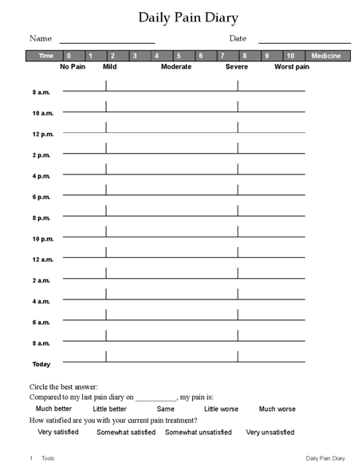
 | The line next to the time is for you to mark how much pain you have at that point in the day. The more pain you have at that time, the farther to the right you should place the mark.

How to Use the Diary, continued | At the top of the page are numbers (0 to 10) and words that describe the degree of pain you are having (No Pain, Mild, Moderate, Severe, and Worst Pain). These words help you decide where on the line you should place your mark.  The dotted line that goes up and down on the page is to help you keep track of where you are on the line. It hits the pain line at about 2 (mild pain) and about 8 (severe pain).  At the bottom of the diary page, there are two questions about your pain.  • The first asks you to compare your pain now to the last time you measured your pain. If this is your first time, leave it blank.  • The second question asks you how happy you are with your current pain treatment. Choose the best answer from those listed.
Daily Pain Diary Example | In the example below, the mark is placed at around 6 on the  0-to-10 scale, which is close to the word “moderate.” This means that at the time the person completed the diary, the pain was a little worse than moderate.
 | 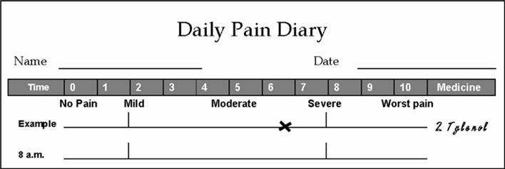
 | Don’t worry about whether your “moderate” is the same as other people’s “moderate.” Just choose the best description, or your best idea of where your pain belongs on the 0-to-10 scale.

